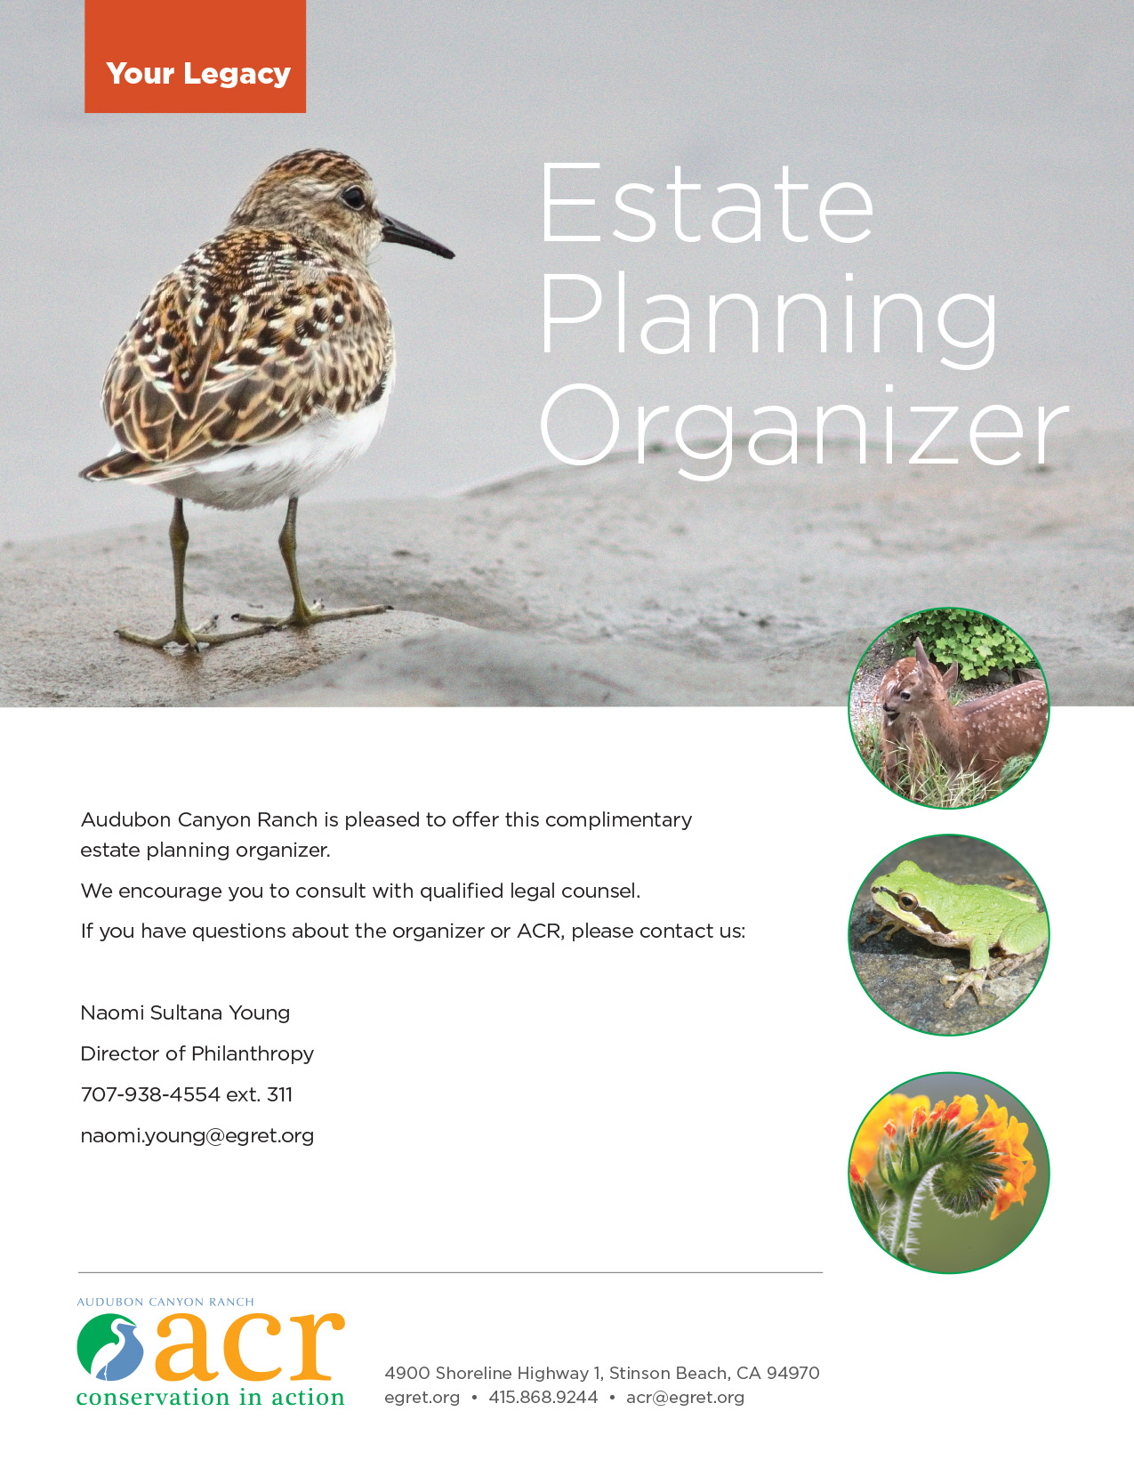
Getting Organized
Recording information related to your estate in one document is a great first step in estate planning - and will allow you, your loved ones and advisers to locate important documents and information quickly.

Estate Inventory Form 2

Personal Legacy Planning 7

Final Arrangements 8

Obituary & Other Information for Friends & Family 10

Miscellaneous Notes, Reflections or Instructions 12

A List of Where Things Are… 13
Your Digital Identity, User Names & Passwords 17

Remembering ACR in Your Will or Living Trust 18

Membership Form for the Clerin Zumwalt Legacy Circle 18

Check documents completed and filed with this Organizer:

[ ] Will
[ ] Living Trust
[ ] Power of Attorney for Property Management
[ ] Advance Health Care Directive

ACR is pleased to offer this complimentary estate planning organizer. We encourage you to consult with qualified legal counsel. If you have questions about the organizer or ACR, please contact us:

Naomi Sultana Young
Director of Philanthropy
707-938-4554 ext. 311
naomi.young@egret.org
Estate Inventory Form

1. Name
Address
City State Zip
Phone (Home)
(Work)
(Mobile)
Email
Date of Birth Place of Birth
Social Security Number U.S. Citizen?
Single Married Widowed Separated Divorced
2. Spouse
Date of Birth Place of Birth
Social Security Number U.S. Citizen?
3. Children
Name Age Address
(A)
(B)
(C)
(D)
(E)
(F)

4. Grandchildren
Name Age Parent
(1)
(2)
(3)
(4)
(5)
(6)
(7)
(8)
(9)
(10)
(11)
(12)
(13)
(14)

The following will give you and your advisers an approximate value of your estate:
5. Real Estate Information (Description = home, vacation, rental, commercial)

A. Description Market Value Debt
Location

B. Description Market Value Debt
Location

C. Description Market Value Debt
Location

D. Description Market Value Debt
Location

E. Description Market Value Debt
Location

F. Description Market Value Debt
Location

G. Description Market Value Debt
Location

H. Description Market Value Debt
Location

TOTAL:
(Total value of real estate = market value less debt)

6. Personal Property Please list approximate current value:

Automobile(s)
Savings and Checking Accounts
Stocks/Bonds
Household Furnishings
Other Personal Assets
7. Death Benefits from Insurance
8. Expected Inheritance

9. TOTAL VALUE OF ESTATE:
(Add all of the above, including total real estate value)

10. Name of Bank(s)

11. Names of stocks, bonds and other investments

12. Executor/Trustee Alternate

13. Funeral Arrangements

14. Beneficiary Information

Persons or Charitable Organizations Listed as Beneficiaries of Your Estate Plan:

1

2

3

4

5

6

7

8

9

10.

11.

12.

Personal Legacy Planning

Questions to consider when planning your personal legacy:

- How do you want to be remembered? By whom?

- What values do you want to pass on to others?

- What kind of legacy do you want to leave to friends, loved ones, your community?

- If you have children, how do you want your children to use this legacy?

- Will beneficiaries be able to use what they receive as you intend?

- What causes do you support? Do you want to support them through your estate?

- Are there other causes you would like to support?

- What is your plan to achieve these goals?

Final Arrangements

The following reflects my wishes regarding my final arrangements. I record them here to guide those responsible for carrying out my wishes and help ensure all arrangements reflect my life, loves and values.
_______________________________________________
Signature Date
If you are associated with a religious group, it is suggested that you complete the following in consultation with the appropriate parties to ensure your wishes are known.
Circumstances permitting, I wish my Burial Service to take place at:
Location
Address, City/ZIP
Celebrant/Minister/Officiator
If you are a member of a religious congregation and wish a traditional ceremony used, specify the nature of the ceremony:
[ ] Burial only
[ ] Burial with additional ritual of:
Suggested pallbearers:

If possible, I would like to have the following readings:
I would especially like the following music or hymns:

Policy regarding acceptance of flowers within religious buildings vary. Instead of sending flowers, many prefer to encourage a more lasting memorial. Most religious groups have a general memorial fund, as do many charities. Memorial gifts may also be made to ACR. (If you so desire, please indicate where you would like to have such memorial contributions made):
I prefer to be:
[ ] Buried
[ ] Cremated
[ ] Before or [ ] after the funeral
Preference regarding the disposal of my ashes
Location of cemetery, lot, deed or columbarium contract:
I have made arrangements to donate my body to:
Funeral home to use:
Coffin or Urn cost: [ ] Least expensive [ ] Mid-range [ ] Elaborate
I do / do not wish to have a viewing at the funeral home.
Other information for loved ones and advisers:

Obituary & Other Information for Friends & Family
Final directions and instructions upon the death of:

Name Date

In addition to recording this information in this organizer, you should share copies with your loved ones and/or adviser(s)
Name (Complete)
Address
Birth Date Place of Birth
Spouse’s Name
Spouse’s Address
Spouse’s Birth Date Spouse’s Place of Birth
Church/Religious Affiliation
Name & address of home church congregation or religious affiliation
Father’s Full Name

Birth Place Living Yes No
Mother’s Full Name
Birth Place Living Yes No
Names, addresses and phone numbers of living siblings:

Names, addresses and phone numbers of other persons to contact upon my death who may not receive notification otherwise:

The following person has agreed to care for my family (or pets) temporarily:

My Occupation
Employer (Name & Address)
Organizations/Associations/Societies/Unions/Lodges/Professional Association, etc.
Include title or position, if past or present, and check if organization is to be notified:

Organization Notify

Charity or charities to be listed in obituary

Miscellaneous Notes, Reflections or Instructions

A List of Where Things Are

At the time of a person’s sudden illness or death, family members, friends and advisers are often faced with the need for specific information. It is important – and extremely helpful - for them to have access to a record of your important papers and information. For couples, each partner should compile separate information and prepare separate documents, although many of the materials will be the same.

The following check list will allow family members, friends and advisers to locate crucial documents and information when needed most. Make sure a family member, close friend or adviser knows where this list is located and share copies with the appropriate parties. Review this list periodically and keep it up to date.

Documents or Information Location
What may be needed in an emergency
Address and phone numbers of doctors, dentists, attorney, home health care workers, family members, close friends
Passport, citizenship papers
Social Security card
Birth certificate
Driver’s license
Marriage certificate
Health insurance cards
Safe deposit box and keys
Home safe and combination
Pre-nuptial agreement
Divorce papers
Adoption paper

Estate Planning Documents | Location
Will
Living trust
Advance health care directive
Power of attorney for property
Desires regarding last ceremonies
Pre-paid burial plot or columbarium
Pre-paid cremation papers
Name and address of executor (Will)
Name and address of successor trustee(s) (Living Trust)
County issuing death certificate:
(A sufficient number of copies are needed to transfer ownership of accounts and titles to property)
Preferred funeral director
Items needed for in case of serious illness | Location
Advance health care directive
Durable power or attorney for property
Financial institutions power of attorney forms (for institution who will not accept the general power of attorney form)
Health care insurance card
Medicare cards

Financial and Investment Documents | Location
Retirement plan(s) statements
Retirement plan(s) - beneficiary designations
Company benefits such as deferred compensation
Investment accounts
Stock certificates not held in an account
Online securities transaction information
Mutual fund account statements
Documents showing basis of stock
Financial Documents (Personal) | Location
Past years’ tax returns
Gift tax returns, if any
Debts owed
Active loans you’ve made to individuals
Mortgage documents
Property tax records
Rental and lease agreements
Real estate deeds
Motor vehicle title papers
Charitable pledges outstanding
Charitable donor-advised fund
Charitable remainder trust & trustee
Appraisal or inventory of valuable tangible personal property (art, jewelry, etc.)
Financial Documents (Bank / Credit) | Location
Passbooks and statements
Checkbooks and statements
Credit cards / statements
Money market accounts / statements
Insurance and Annuities | Location
Life insurance documents
Group life insurance
Health and auto insurance cards
Home insurance
Other property insurance (rental)
Commercial annuities
Charitable gift annuities
Beneficiary forms for insurance polices
Veterans insurance benefits
Miscellaneous Items | Location

Your Digital Identity, User Names & Passwords
Today, almost everyone uses the internet. If you have accounts with Google, Facebook or Amazon, use online banking or business services, or have a website – someday family members, friends and/or advisers will need to be able to access these accounts.
For security reasons, it is not suggested you create a single list of all user names, passwords and security question answers for your online accounts. However, you should determine a way in which to convey this information to the appropriate people.
If you do create one or more lists, keep them secure at all times. However you protect this information, be sure designated parties can gain access to it when needed. Ask a trusted family member or friend to keep a copy on your behalf. Only people you want to access this information should be able to – and only when and how you wish.
Typical information needed to access online accounts includes email address, user name, password and answers to security questions, as illustrated below. Check to see what information is needed for each of your active accounts – and be sure someone can access each account with the information recorded.
Account Account Type User Name Email Address Password Security Answer?
Gmail Email jreid jsr@gmail.com 16candle Prospect street
Amazon Online Retail Fsmithcg Fsmith@att.net Home456 Murphy

Remembering ACR in Your Will or Living Trust

To make a charitable bequest to ACR, consider adding wording like this to your will or living trust:

“I give { percent of my estate, or description of asset, or $ dollars} to Audubon Canyon Ranch (Tax ID: 94-6069140), located in Stinson Beach, CA, to further its nonprofit mission.”

Clerin Zumwalt Legacy Circle Membership Form

If you have included ACR in your will or living trust, or in your estate plan in some other way, we would be honored to list you as a member of the Clerin Zumwalt Legacy Circle.

Please complete this form and mail or email a copy to:

Naomi Sultana Young
Audubon Canyon Ranch
PO Box 577, Stinson Beach, CA 94970
naomi.young@egret.org

Dear Ms. Young,
(check one:)
[ ] I have remembered ACR through a bequest in my will or trust or in some other way. Please enroll me in the Clerin Zumwalt Legacy Circle. You may publish my name in the membership list for the Clerin Zumwalt Legacy Circle.
[ ] I have remembered ACR through a bequest in my will or trust or in some other way. Please enroll me in the Clerin Zumwalt Legacy Circle. Do not, however, publish my name.

Name(s) (Please Print) ________________________________________________________

Address____________________________________________________

City______________________________________ State ___ Zip ______

Signature(s): ________________________________________________ Date: ___________

The more information we have regarding your gift, the better able we are to honor your wishes. If you are comfortable doing so, please note the type of gift you have made. Completing this section is not required for Legacy Circle membership nor does this form have any legal force.

We have provided for ACR as follows:

[ ] Charitable bequest (Indicate type): [ ] specific amount
[ ] percentage
[ ] whatever’s left over (residual)
[ ] if all heirs are deceased (contingent)
[ ] Retirement plan designation
[ ] Insurance designation
[ ] Charitable gift annuity
[ ] Charitable trust
[ ] Other ____________________
[ ] Estimated gift value (optional) ____________

Person or party responsible for the transfer of your gift: ________________________________________________________________

